2020 CO/HOA/STL Virtual Education Day Panelists - COVID-19 Planning at University Campuses

Wayne Northcutt
Facilities Planner
University of Colorado Boulder
Wayne Northcutt is a campus planner, specializing in science and research facilities. Also a licensed architect, Mr. Northcutt has planned almost $400M in facilities during his ten+ years with the University of Colorado Boulder. Originally a chemical engineering major, Wayne received a Bachelor of Arts in Environmental Design from the University of California Berkeley and a Masters of Architecture from the University of Michigan in 1995.
Brad Johnson  Project Manager – Engineering & Capital Construction  Colorado State University  brad.scott.johnson@colostate.edu | 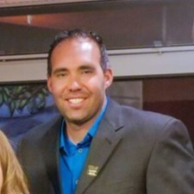
Brad Johnson is a project manager within the CSU Capital Construction team since 2019. His professional experience has been primarily focused around the planning, design and construction of various types of projects including higher education, medical, and a data center. Notable projects include the Ent Center for the Arts and Hybl Sports Medicine Performance Center. Growing up in Nebraska, he attended the University of Nebraska at Kearney where he received a Bachelor’s degree in Construction Management. While working at the University of Colorado Colorado Springs, he studied for a Master’s in Public Administration. Since joining CSU, he has been working on the Temple Grandin Equine Center and since July been tasked with COVID Testing Logistics and Operations project management.
Joe Kimitch, sfp fmp LEED AP BD&C  Staff Engineer  University of Colorado Denver | Anschutz Medical Campus | 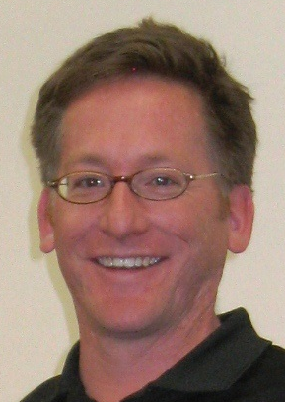
Joe has 20 years’ experience in the Building Automation System industry. Manages controls and lighting systems for Facilities Management at the University of Colorado Denver | Anschutz Medical campuses. Performs integration and programming of multiple technologies, platoforms, and user interfaces. Engineering department representative for design, construction, and commissioning of new buildings and retrofit projects. Develops specifications and sequence of operations for HVAC and lighting equipment. Assists in the program plan and development of deferred maintenance, controlled maintenance and energy conservation projects. Joe is a member of APPA, IFMA, USGBC, and an active Board Member of the Colorado Chapter of the International Institute of Sustainable Laboratories (I2SL).
Mark Reiske, RA  Director of Facilities Planning and Development  University of Kansas | 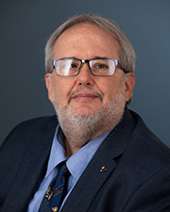
Mark has a bachelor degree in Architecture from the University of Kansas. He has been with the University of Kansas since 1989 and has 31 years of experience. During that time, he has gone from an entry level architect at the University to now being the Director of Facilities Planning and Development.
As the director of Facilities Planning and Development, Mark oversees a professional staff of 20 including architects, landscape architects and engineers who design and or manage projects being done at the University. Some of his day to day duties include providing guidance and support to the office’s project managers, office management, long range planning for the University and assuring that Facilities Planning and Development is meeting the expectations of its clients and the University’s administration.
Over the years, Mark has overseen a wide variety of projects at the University as well as managing KU’s in house construction team for part of that time. Project types include educational, housing, healthcare, infrastructure, athletics and commercial. During the pandemic, Mark has worked on a variety of University initiatives to prepare the campus for on campus learning.
Alicia Hubert  Sustainability Coordinator  Washington University School of Medicine in St. Louis | 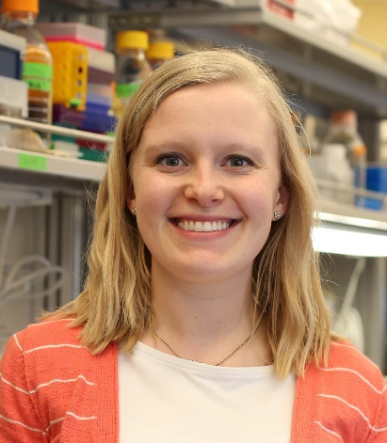
Alicia Hubert is the Sustainability Coordinator for the Washington University School of Medicine. She leads the Green Lab Program for WashU and has several years of experience working in labs. She holds a Bachelor of Science in Zoology and a Master of Science in Ecology, Evolution, and Systematics. Alicia is interested in promoting change at the user level by educating and assisting researchers in making sustainable choices in their daily lab practices and experimental design.
Rachel Henken, Ph.D  Laboratory Safety Coordinator  University of Missouri St. Louis | 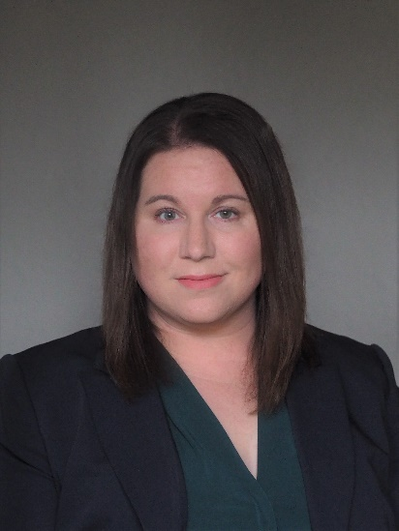
Rachel Henken is the Laboratory Safety Coordinator for the Environmental Health and Safety Department at UMSL. She holds a B.S. in Biology and Chemistry from Truman State University and a Ph.D. in Chemistry from Louisiana State University. She is an advocate for sustainability in UMSL labs and through her volunteer work with Gateway Greening.
Brooke Hay
Assistant Vice President
Facilities, Planning and Capital Programs
University of Nebraska
Brooke Hay is Assistant Vice President of University of Nebraska Facilities, Planning, and Capital Programs and leads the Capital Construction team of Facilities Planning and Construction. She focuses on strategic planning, program management, client care, project metrics, resource development, and compliance. Brooke is the project executive on projects over $500,000, projects at UNK, and others as needed at UNL, UNO, and outstate facilities. With a team of 10 (engineers, architects, construction managers and an interior designer) these capital projects are led from conceptualization through warranty, with different delivery methods and project partners, clients and stakeholders.

Brooke has her B.S. in Civil Engineering from the University of Nebraska-Lincoln and a PE license in Nebraska. Brooke lives in Palmyra, Nebraska, with her husband and children Liatris (10) and Hubbard (6)

